In the context of Interior Design, "form" is one of the fundamental elements that contributes to the aesthetic and functionality of a space. Form refers to the three-dimensional shape and structure of objects within an interior environment. It encompasses everything from the architectural elements of a building, the physical appearance and arrangement of objects and furniture, to the decorative details within it. Form defines the physical contours and volume of objects, playing a valuable role in shaping the overall feel and usability of a room.

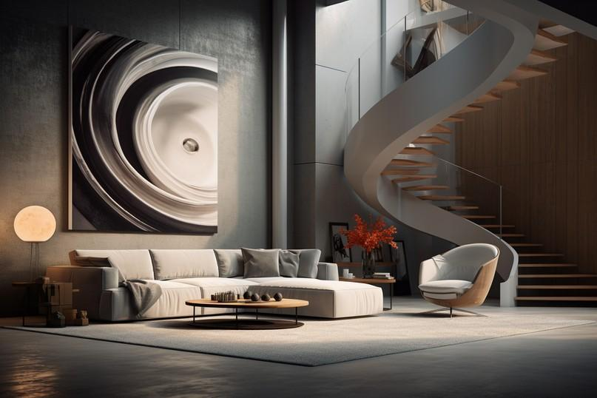

Fig. 1. Unsplash (n.d.), A room with different forms

# How do we read Form?

In order to fully understand Form, let us break it down into its visual elements:

## Shape:

The outline or contour of an object. Shapes can be simple (like a circle or square), or complex (like intricate patterns or irregular outlines). The shape of an item can influence the perception of a space. For example, rounded shapes often feel softer and more inviting, while angular shapes can appear more modern and dynamic.

## Structure:

The internal organisation of a form. This includes the framework that gives an object its form, and the way in which its parts are arranged. For instance, the skeletal structure of a chair determines its sturdiness and comfort, while the intricate carvings on a piece of wooden furniture define its aesthetic.

## Configuration:

The way different shapes and structures come together to form a cohesive whole. This can involve the way in which a bed is configured. For example, it could be a sturdy ottoman bed, or perhaps an intricate metal framed bed. It can, however, also, involve the arrangement and relationship between different forms within a space. For example, a well-configured living room will have furniture and decor arranged in a way that promotes flow and functionality.

The above elements work together to define a Form as Open or Closed:

## Open Forms:

These are forms that do not completely enclose space and often have an airy, inviting feel. They promote a sense of openness, and can make a space feel larger (Fig. 5) . Examples include open shelving units, or furniture with legs that lift the piece off the ground, creating a visual gap between the furniture and the floor. In terms of configuration, open forms are arranged to maximise a fluidity in space and movement. Open-plan living areas, where the boundaries between different zones are blurred, are a prime example.

## Closed Forms:

These are forms that are solid and self-contained, creating a sense of enclosure. They often make a space feel more intimate and grounded (Fig. 5). Examples include solid block sofas or enclosed cabinets. Closed forms are configured to create distinct, separate areas within a space. This can help in defining different functional zones, such as a closed-off kitchen or a private reading nook. The arrangement often includes barriers like walls, partitions, or large furniture pieces that clearly delineate space.

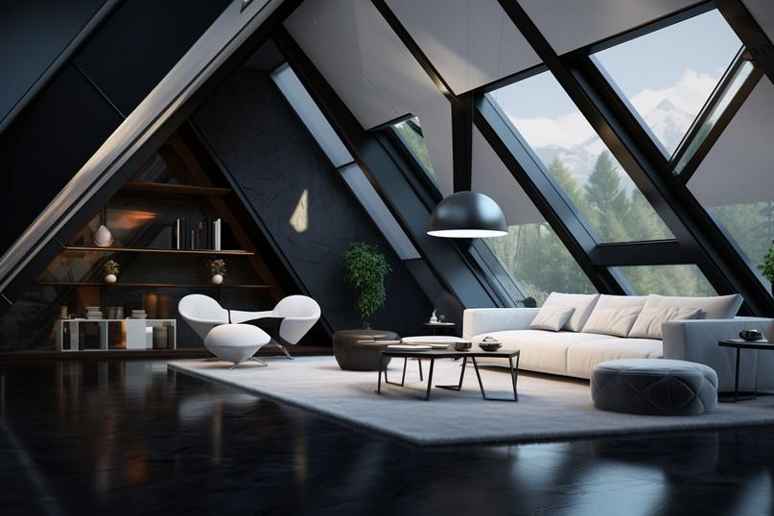

Fig. 2. Pexels (2024), Interior Space with Geometric Forms

# The Importance of Form in Interior Design

## Visual Interest

Form is an important element in adding visual interest to an interior space. Different shapes and structures create focal points that draw the eye, guiding the viewer's gaze around the room. By thoughtfully arranging forms, designers can create a dynamic and engaging environment.

**Balance and Harmony**

Using a mix of forms can achieve balance and harmony in a space. For example, combining geometric and organic forms can result in a room that feels both structured and inviting.

## Functionality

The form of objects directly affects their usability and comfort. Furniture with ergonomic forms enhances comfort, while practical forms in cabinetry and fixtures can improve functionality. For example, an ergonomically designed chair provides better support, making it more comfortable for long periods.

# Applications of Form in Interior Design

## Furniture Design

The form of furniture pieces will determine their aesthetic appeal, style, and practical function. Sleek, angular sofas may suggest modernity and sophistication, while curvaceous armchairs might evoke comfort and tradition. The form of furniture should complement the overall style of the space, while also meeting functional needs.

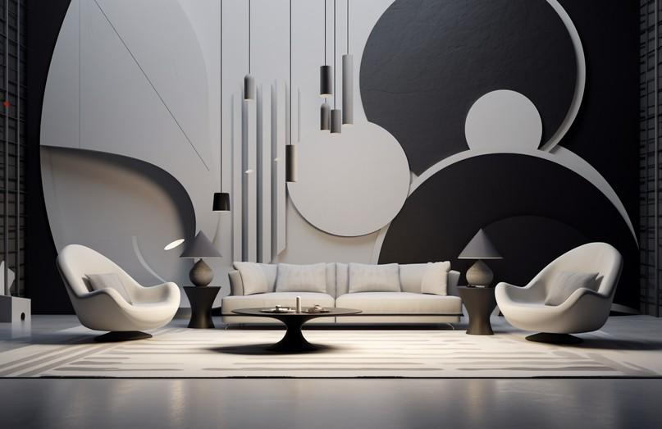

Fig. 4. AI Generated (2024), Interior Space with a combination of Form types

## Architectural Elements

Architectural elements such as arches, columns, and mouldings are forms that contribute to the character and style of a space. These elements can define the architectural style, from classical to contemporary, and provide structural interest. For example, arched doorways can add a sense of grandeur, while clean-lined mouldings can enhance a modern aesthetic.

## Decorative Accessories

Decorative accessories, such as vases, sculptures, and light fixtures, come in various forms that can complement or contrast with the larger elements in a room. These accessories add layers of interest, and can be used to reinforce the room's style, or introduce new visual elements. A sculptural light fixture can become a statement piece, while a collection of differently shaped vases can create a harmonious display.